
Import & Export Data (CSV, Excel, JSON)

🔹 Reminder
- Yesterday: we created DataFrames manually (dict → DataFrame).
- Today: data usually comes from files (CSV, Excel, JSON) or APIs.

🔹 Data Formats

Notes
- CSV → Most common, simple, readable.
- Excel → Business world, multiple sheets.
- JSON → API/web services, nested structures.

Examples
students.csv
Name,Age,City
Alice,25,Nairobi
Bob,30,Mombasa
students.xlsx → same as above, saved as Excel.
students.json
[
{"Name": "Alice", "Age": 25, "City": "Nairobi"},
{"Name": "Bob", "Age": 30, "City": "Mombasa"}
]
Use in Data Science:
- CSV → Kaggle datasets.
- Excel → corporate records.
- JSON → web APIs (Twitter, Weather).

🔹 Importing Data

Practical – Reading Different Formats
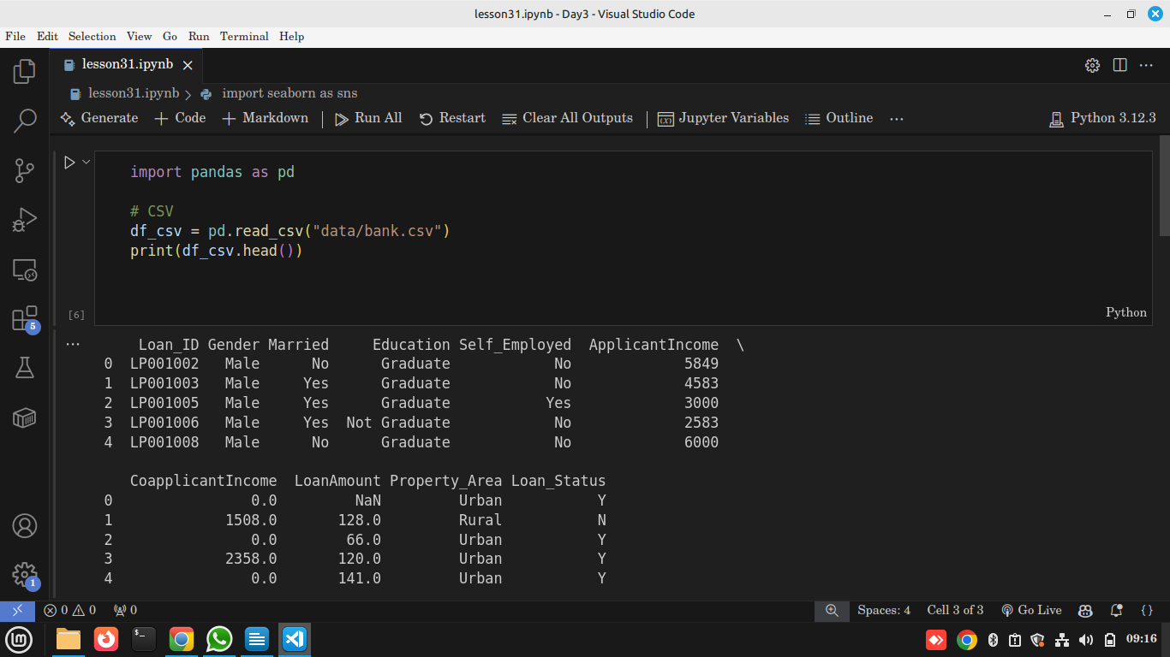
- pd.read_csv() → loads CSV into DataFrame.
- pd.read_excel() → needs openpyxl installed.
- pd.read_json() → parses JSON into DataFrame.
Use in Data Science
These are entry points for every project — from raw file → DataFrame → analysis.

🔹 Exporting Data

Practical – Saving Data
# Save to CSV
df_csv.to_csv("output.csv", index=False)

# Save to Excel
df_csv.to_excel("output.xlsx", index=False)

# Save to JSON
df_csv.to_json("output.json", orient="records")
Explanation
- index=False → avoids extra column.
- orient="records" → JSON-friendly format.
Use in Data Science
Exporting lets you share cleaned/processed data with colleagues, dashboards, or ML pipelines.

🔹 Hands-On: Titanic Dataset
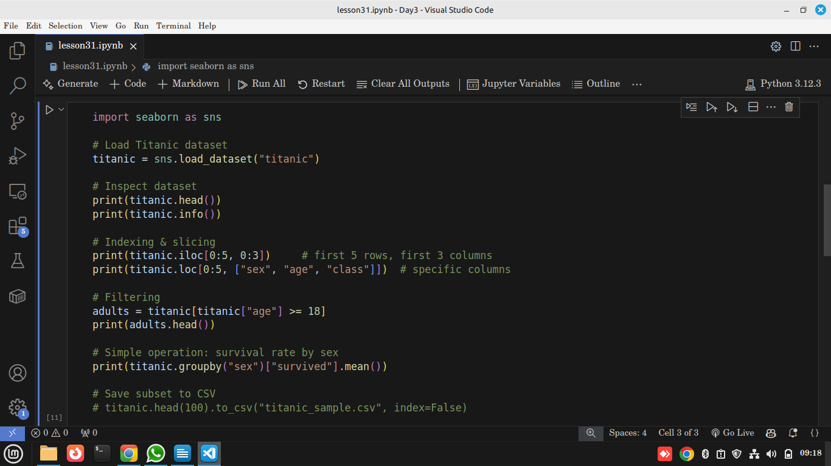
Sample Output
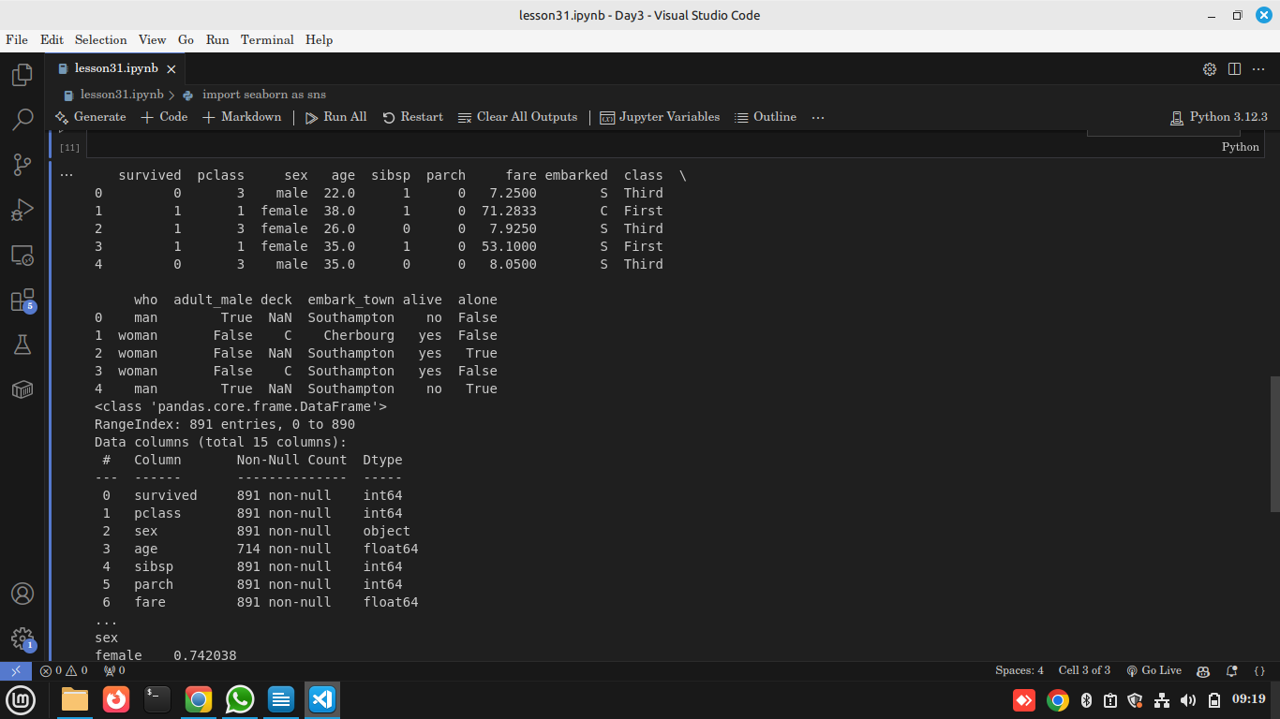
Explanation
- iloc → integer-based indexing.
- loc → label-based indexing.
- Filtering (e.g., age ≥ 18) → data wrangling basics.
- .groupby("sex") → real analysis: shows women had higher survival rates.
- .to_csv() → saves results for later.
Use in Data Science
This shows how imported data can immediately be inspected, filtered, and analyzed — bridging file formats with real analysis.

🔍 Reflection
- Which format is most common? (CSV).
- Why use JSON? (APIs / real-time data).
- Why is Excel risky? (Formatting errors, multiple sheets).
- How does indexing/slicing help? (Lets us zoom into relevant data quickly).

